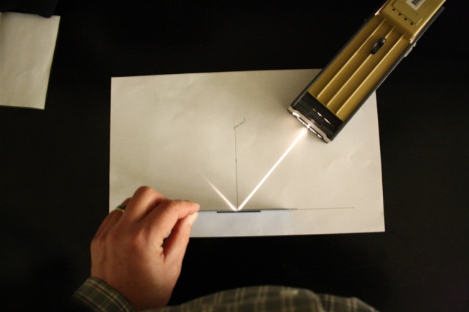 Plane Mirrors – Light Reflection

**Introduction**



The law of reflection simply states that the angle of incidence for a light ray coming into a reflecting surface (such as a mirror) is equal to the angle of reflection. These angles are measured with respect to a line perpendicular to the reflecting surface (often called the normal to the surface) as shown in Figure 1. In the case of plane mirrors, the image is said to be a **virtual image**. Virtual images are images that are formed in locations where light does not actually reach. Whenever a mirror (whether a plane mirror or otherwise) creates an image that is virtual, it will be located behind the mirror where light does not really come from.

**Objectives**

* SOL PS.9 – a, b
* Trace light rays as they reflect from a plane mirror and draw conclusions about the law of reflection

**Materials**

Plane Mirrors

Wood Blocks

Protractor

Metric Ruler

Laser Pointer

Masking Tape

**You will be using a low power laser in this experiment that requires some caution in its use. ALWAYS keep the laser on the table top when in operation and be aware of where the laser is pointed before turning it on. NEVER look directly into the laser beam since eye damage could result.**

**Setup**

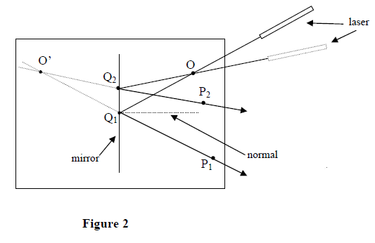

**Procedure**

1. Fold a blank white sheet of paper in half (hamburger style). Using a ruler, draw a straight line along the fold that you just made.
2. Tape the plane mirror to one of your wooden blocks, so that the mirror will be held up in a vertical position. Care should be taken so that the tape does not get on the front surface of the mirror.
3. Place the *back edge* of the mirror on the line that you drew in step 1. For the rest of the experiment the mirror should remain along this line.
4. Place a dot on your sheet of paper about 10 cm from the mirror and perhaps 5 cm to the right of center of the mirror (see Figure 2). Label this position “O” on your paper.
5. Place the laser as shown in Figure 2 and adjust its position so that the beam skims along the surface of the paper. The beam should intersect the pin at O and reflect off of the mirror.
6. Place a second dot in the path of the reflected ray and label “P1” (see Figure 2).
7. Mark on your paper the point “Q1” below where the laser beam strikes the mirror (see Figure 2).
8. Shift the laser’s position so that the beam passes across dot “O” in a slightly different direction (again see Figure 2).
9. Repeating the procedure of steps 5 – 7 above, locate and mark points P2 and Q2.
10. If time permits, repeat this procedure one more time and locate points P3 and Q3 (not shown in Figure 2).
11. Turn off the laser and remove the mirror from your paper sheet.

**Analysis**

1. Using a ruler, draw lines from O to Q to P for each of your light rays. Put an arrow on each ray to show the direction of its travel. Draw a perpendicular dashed line (the normal) that is perpendicular to the mirror surface at each point Q on your paper.
2. Using a protractor measure the angle of incidence and the angle of reflection for each light ray. Calculate the percent difference between the angle of incidence and the angle of reflection for each light ray and record all numbers in the data table.

|  |  |  |  |
| --- | --- | --- | --- |
| **Light Ray** | **Angle of Incidence (deg)** | **Angle of Reflection (deg)** | **Percent Difference** |
| **1** |  |  |  |
| **2** |  |  |  |
| **3** |  |  |  |

1. Notice on your sheet the line QP. Extend each of these lines (use a dashed line) back behind the mirror to a point where they intersect (see Figure 2). Label this point O’. This is the point where all reflected rays appear to originate. We call this point the image of the object at O.
2. Measure the shortest distance from O to the mirror and call this the object distance. Measure the shortest distance from O’ to the mirror and call this the image distance. Find the percent difference between the two distances and record this information in the table.

|  |  |  |
| --- | --- | --- |
| **Object Distance (cm)** | **Image Distance (cm)** | **Percent Difference** |
|  |  |  |

**Conclusions**

1. Describe the image that is formed by a plane mirror. Is it virtual or real? Upright or inverted? Bigger, smaller, same size?
2. How well do the results of your experiment confirm the law of reflection? Discuss any sources of error that you can think of.
3. What conclusion can you draw concerning the image distance compared to the object distance when dealing with reflections in a plane mirror? Discuss sources of error.
4. Challenge: Suppose you wanted to see your complete reflection in a plane mirror mounted on a wall. What minimum length does the mirror have to be in order to see your entire reflection? **Hint:** On a separate sheet of paper make a light ray diagram like you did for this experiment and show a light ray that comes from the top of your head to the mirror and then to your eyes. Similarly, draw another ray that leaves from your feet and arrives at your eyes.