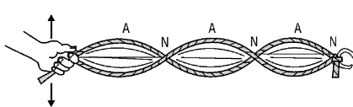
Making Waves – 2
Part 2: Standing Waves
Introduction

In this activity, students in small groups will explore the relationship between common wave characteristics and a wave’s speed. A simple metal slinky will be used to make the waves of various types and amplitudes.

Objectives

Virginia Middle School Physical Science Standards:
- PS.6 – Transfer of energy
- PS.8 – Sound waves
  - wavelength, frequency, speed, amplitude, rarefaction, and compression;
c) the nature of compression waves; and
- PS.9 – Transverse Waves
  - wavelength, frequency, speed, amplitude, crest, and trough;

- Students will understand how to make, recognize, and identify types of standing waves
- Students will understand an alternative method for finding the speed of a wave
- Students will understand the connection between wave pulses and standing waves

Materials, Setup
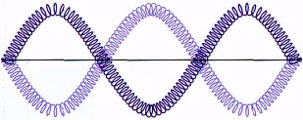
Meter stick

Slinky or Snakey, stretched to about 3-5 meters, between two group members

Timer or stopwatch

Tape or floor tiles to mark different amplitudes

Procedure, Data, Calculations and Results

Swing one end back-and-forth over and over again along the floor. To make these waves look very simple, change the way you swing the end until you see large waves that do not move along the spring. You will also see points where the spring does not move at all. These waves are called standing waves.

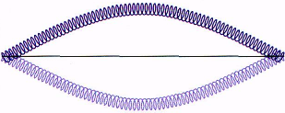
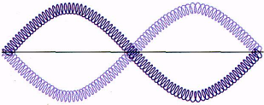
The distance from one crest (peak) of a wave to the next is called the wavelength. Notice that you can find the wavelength by looking at the points where the spring does not move. The wavelength is twice the distance between these points. By making more anti-nodes on your standing wave, the wavelength decreases, as show below:
Wavelength = twice slinky length Wavelength = slinky length Wavelength = 2/3 slinky length

You can also measure the wave frequency. The frequency is the number of times the wave moves up and down each second. Measure the frequency of your standing wave. Hint: Watch the hands of the person shaking the spring. Time a certain number of back-and-forth motions. The frequency is the number of back-and-forth motions of the hand in one second.
Make several different standing waves by changing the wave frequency. Try to make each standing wave shown in the drawing. Measure the wavelength. Measure the frequency. Record your data in the table below.

Wavelength (m/cycle) | Frequency  (cycles/s or Hz) | Speed (m/s)  wavelength X frequency

For each wave, calculate the product of the wavelength and the frequency. Find the average.

Conclusions

Compare these values with the average speed of the pulse that you found in Making Waves - Part 1.
What do you notice?

