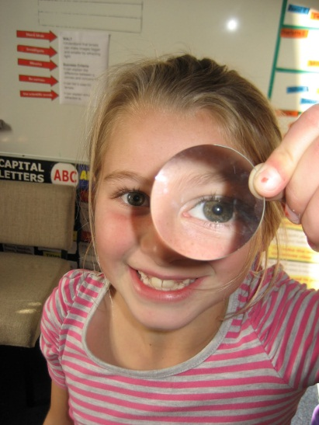
Refraction of Light – Lenses

Introduction

Converging lenses can produce both real and virtual images; diverging lenses can produce only virtual images. In this experiment we shall study image formation by a converging lens. A spherical lens made of crown glass has a focal length very nearly equal to its radius of curvature, a fact commonly used in lens diagrams.
When an object is illuminated, each point on its surface acts as a source of diverging rays. When some of these rays from a point on the object are incident on a converging lens properly placed, they converge at a point on the opposite side of the lens, forming an image of the object point. Collectively, these image points form an image of the object. Since the rays of light converge to form the image, it is a real image and can be projected on a screen.
If a lens is less than its focal distance from an object, the refracted rays do not converge and no real image is formed; instead a virtual image is formed. A virtual image can be seen by the eye looking through the lens in the direction of the object, but the image cannot be formed on a screen.
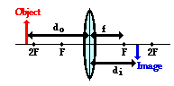
A converging lens can be used to form an image on a screen of an object. The lens equation relates the focal length f of a lens, the object distance d_{o} and the image distance d_{i},
Objectives

- SOL PS.9 – a, b
- After completing this experiment, you should be able to determine the focal length of any converging lens and understand its image forming characteristics.

Materials

Converging lens Candle
2 meter sticks Masking tape
index card (screen) Metric ruler
holders for mirrors, screen, and candle Paper towels

Setup
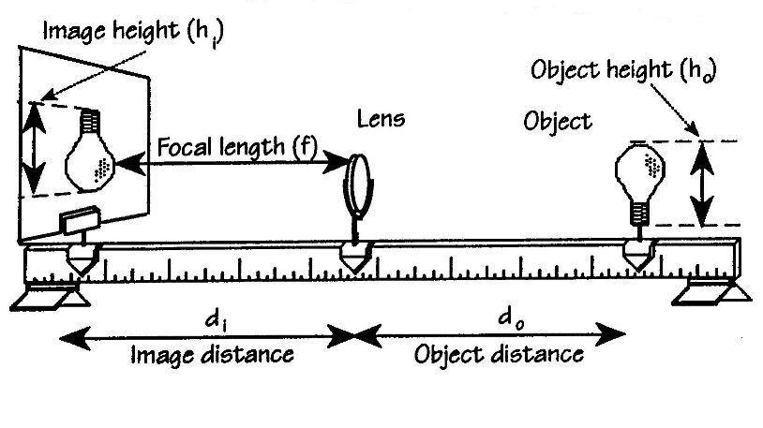
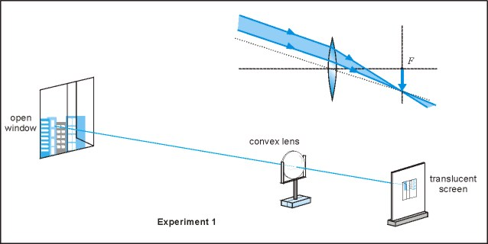

Procedure

IMPORTANT: Be safety-conscious around the candle flame! If you have long hair, tie it back. Roll up any long, loose sleeves. Keep your face away from the candle flame.
- Place the converging lens in a lens holder. If you do not have a lens holder, use your hand. Put the lens and a paper screen on a meterstick. Using the sun’s parallel rays, find the focal point by focusing its image onto the screen and measuring the distance from the lens to the screen. Move the screen back and forth until the sharpest image is obtained. See Experiment 1 above.

Focal length of converging lens: ___________ cm

- Set the lens in the lens holder or hold the lens in the center of the meterstick. Place the object (the candle or light bulb) beyond the 2f of the lens. By moving the screen back and forth, find the sharpest image on the screen placed on the opposite side of the lens. Measure and record in the data table the object distance, d_{o}, from lens to the object and, the image distance, d_{i}, from the screen to the lens. Make a comparison of the size of the image compared to the size of the object.
- Place the object on the 2f from the lens. Move the screen back and forth until the sharpest image is obtained. Record the object and image distances. Compare the image size to the object size.
- Locate the object between 2f and the f. Move the screen back and forth until the sharpest image is obtained. Record the object and image distances. Compare the image size to the object size.
- Place the object between the f and the lens. Try to form an image on the screen. Remove the screen and, placing your eye close to the lens, look through the lens at the object. Describe what you see.

Image description: ____________________________________________________

Position of object | Beyond 2f | At f | Between 2f and f
d_{o}
d_{i}
Image size compared to object size
Type of image: real, none, or virtual
Direction of image: inverted or upright

Analysis

- For each of the real images that you observed, use the lens equation to calculate f. Do your calculated values agree with each other?

- Average the values of f that you calculated in the previous question and compute the percent difference between the average and the measured value for f recorded in the data table.

Conclusions

- Make some general observations related to the three different conditions that allowed an image to be formed on the screen. Make sure to discuss real vs. virtual image, the size of the image compared to the object, and whether or not the image was inverted or upright.

- What did you observe in the final situation when you could not obtain an image on the screen? Describe your observations.

- With the lens fixed in position, if the object is placed a long way from the lens and gradually moved towards the lens, describe what happens to the image.

