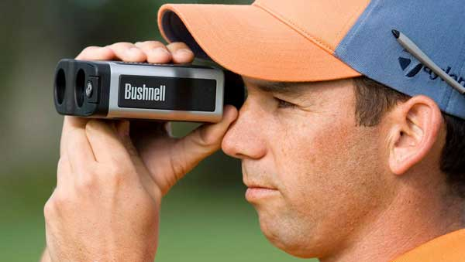
Reflection of Light – Laser Golf

Introduction

When a wave hits a boundary, three different events can occur. The wave may be:
- Reflected – wave bounces off a boundary
- Transmitted – wave is transmitted into the new medium
- Absorbed – energy of the wave is transferred into the boundary medium

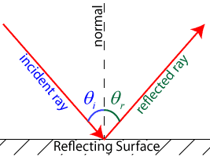
The law of reflection states that the angle at which a wave strikes a reflective medium (the angle of incidence, or Θ_{i}) is equal to the angle at which a wave reflects off the medium (the angle of reflection, or Θ_{r}). Put more simply, Θ_{i} = Θ_{r}. In all cases, the angle of incidence and the angle of reflection are measured from a line perpendicular, or normal, to the reflecting surface.
Although all waves can exhibit these behaviors, electromagnetic light waves are typically considered for demonstration purposes. When a wave bounces off a reflective surface, the nature of its reflection depends largely on the nature of the surface. Rough surfaces tend to reflect light in a variety of directions in a process known as diffuse reflection. Diffuse reflection is the type of reflection typically observed off of pieces of paper. Smooth surfaces tend to reflect light waves in a more regular fashion, such that the reflected rays maintain parallel reflected rays. This process is known as specular reflection, and is commonly observed in mirrors.
Objectives

- SOL PS.9 – a, b
- To use the law of reflection to bounce laser light on to a target.

Materials

Laser
4 Plane Mirrors
Blocks of Wood
String
Protractors
Rulers (or metersticks)
Procedure
- You will have a target with point levels situated on the end of the table.
- You must setup 2 mirrors to take the path of a laser beam and hit the target to gain points.
- Align the mirrors as you see fit using string provided.
- You will be given two shots.
- Make sure to align a string for the incoming laser beam so that your teacher can come over and shoot along the desired path.
- 1st Shot (Mulligan): Once you are ready, call your teacher over with the laser and have him align it along the inbound pathway of your choosing. You are not allowed to touch the table during the first shot. You can, however, look at the location of your first shot and decipher where you need to correct.
- After your first shot, your teacher will turn off the laser and you can go about adjusting your table. When ready call your teacher over for your 2nd Shot.
- 2nd Shot: Like the first you cannot touch the table. This is your “official” shot - These points will count toward your score.
- Now, find the second target near the front of the room and repeat the procedure above. At least one mirror must be on a different table.

Note to teacher: You can make this exercise more challenging by simply increasing the number of mirrors that must be used to guide the laser beam to the target.

Scoring

  - Each counted shot counts for 1-6 points. Which means you can score a 12 out of 10 for this activity grade.

Initial Target Shot: ____ pts out of 5
Second Target Shot: ____ pts out of 5

Template for Laser Golf Target

