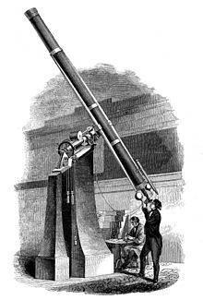 Building a Telescope

Adapted from NASA – Optics: An Educator’s Guide with Activities in Science and Mathematics (<http://www.nasa.gov/pdf/58258main_Optics.Guide.pdf>)

**Introduction**

A Dutch optician, Hans Lippershey, designed the convex lens for the first refracting telescope in 1608. He found that a distant object appeared to be much closer when he looked at it through a concave lens and a convex lens held in front of each other. He put the lenses into a tube to make the first refracting telescope.

Galileo made the first refracting telescope used to study space in 1609. He used it to discover four of the moons orbiting Jupiter. Galileo also used his refracting telescope to map the surface of the moon. Galileo could see objects 20 times smaller than the human eye could using his telescope.

In a telescope, the lens held next to your eye is called the eyepiece and is usually a short focal length lens or a combination of lenses. The lens at the other end of the telescope is called the objective lens. Light from a distant object is focused by the objective lens to form an image in front of the eyepiece. The eyepiece acts as a magnifier and enlarges that image. The magnification of the telescope can be found by dividing the focal length of the objective by the focal length of the eyepiece.

**Objectives**

* SOL PS.9 – a, b
* To construct a simple refracting telescope and calculate the magnification.

**Materials**

2 converging lenses (convex lenses)

Telescoping tubes (mailing tubes)

Manila file folder

White poster board

Red and black tape

Scissors

Knife or saw

Glue

**Setup**

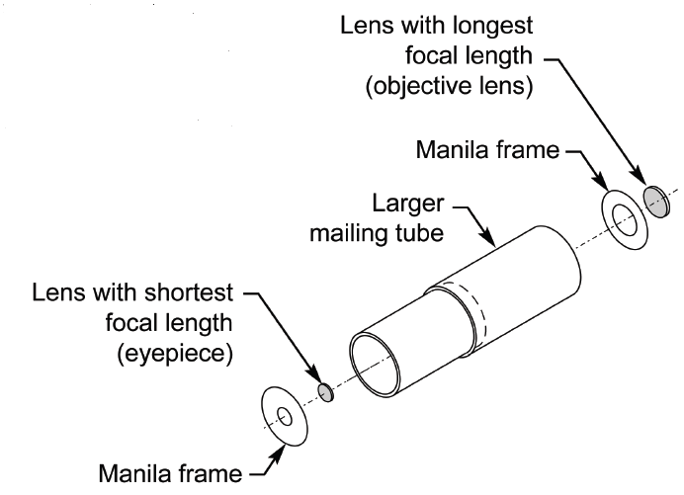

**Procedure**

1. The mailing tubes will be the body of the telescope with the smaller one sliding inside of the larger one. The length of the assembled telescope will be a little longer than the sum of the focal lengths of the two lenses. Add the value of the focal lengths of the short and long lens together. Divide that length by two and then add another inch. Cut both of the tubes to that length with the knife or saw. *If you have the telescoping tubes, you only need to adjust the tubes to the appropriate length (no cutting should be necessary).*
2. Use the scissors to cut out two circles from the manila paper that are the same size as the diameter of the mailing tube. These circle frames will mount and center the lenses on the tube. With a knife (or scissors), cut out circles that are slightly smaller than the diameter of the lenses in the center of the paper frame circle. Glue the lenses to the center of the frame. The shorter focal length lens will be the eyepiece. Glue that framed lens to the end of the smaller tube. Glue the other framed lens to the end of the larger tube.
3. Slide the two cardboard tubes together. You have now assembled a simple refracting telescope. Look through the eyepiece of your telescope and focus it on a distant object. Slide the two cardboard tubes in and out until you have a clear image. What do you observe?
4. Use the red and black tape to make stripes on the white poster board to use as a chart.

**Analysis**

1. To compute the power or magnification (M) of your telescope, you will use the focal lengths given to you by your teacher. Insert the number for each focal length into the following equation:



**The magnification of my telescope is:**

**______________________________**

1. Evaluate your calculated magnification. Stand at one end of the room and look at the chart with red and white stripes, and black and white stripes. Look directly at the chart with one eye and look through the telescope with the other eye. This may be a little difficult at first, but with a little practice you will find that you can do it. How much is the chart magnified?

**Conclusions**

1. Describe the image that is formed by a refracting telescope. Is it virtual or real? Upright or inverted? Bigger, smaller, same size?
2. Did the amount of magnification observed through your telescope match the magnification you computed for your telescope? Discuss sources of error.
3. In observing objects through your telescope, did the image appear clear? Why or why not?